Jenkins backup:

We can do two ways

1.Backup

2.Thinbacup

1.backup manager:

Step 1: install the backup plugin from manage plugin 🡪 available 🡪 search(plugin-name) 🡪 choose and click on install without restart. After install the plugin we will get the backup manager option manage Jenkins board as shown below screen shot.

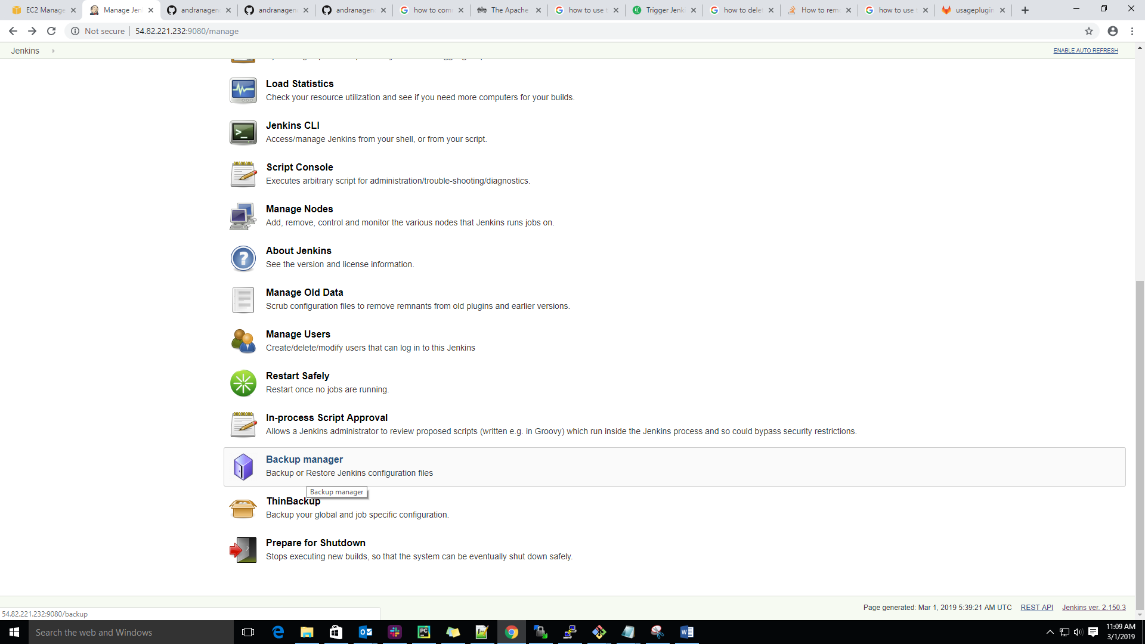

Step 2: Now, we need to double click on Backup manager then we get the new window as shown below screen shot.

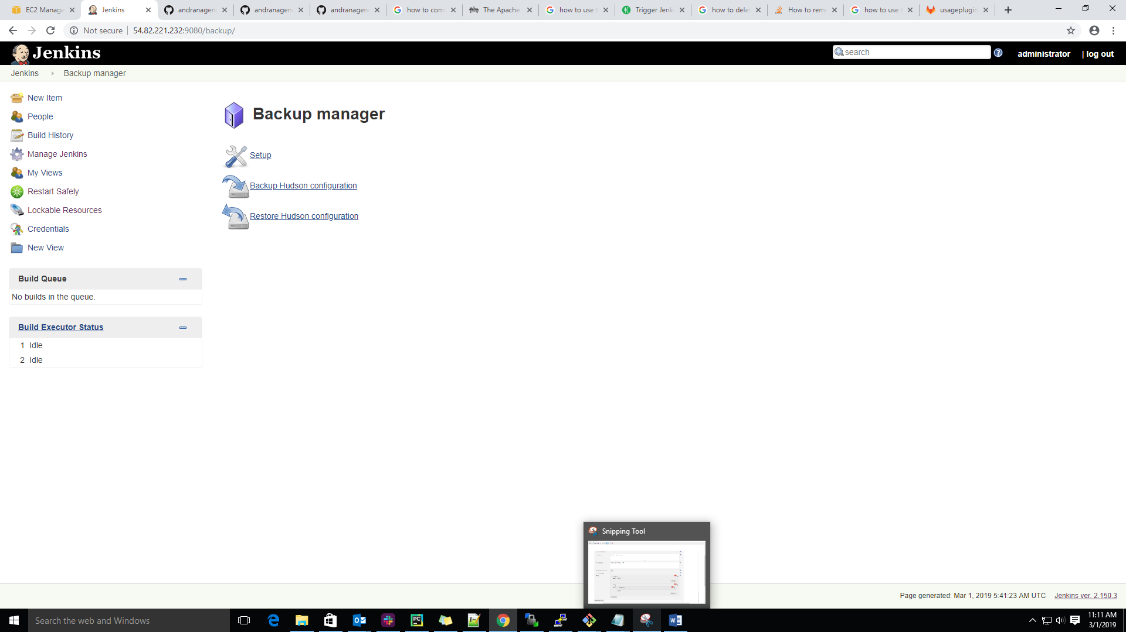

Step 3: Here, we are giving the **Backup destination path**, before we need to create the backup destination directory.

mkdir /home/Jenkins-backup in Linux

mkdir c:/ Jenkins-backup in windows

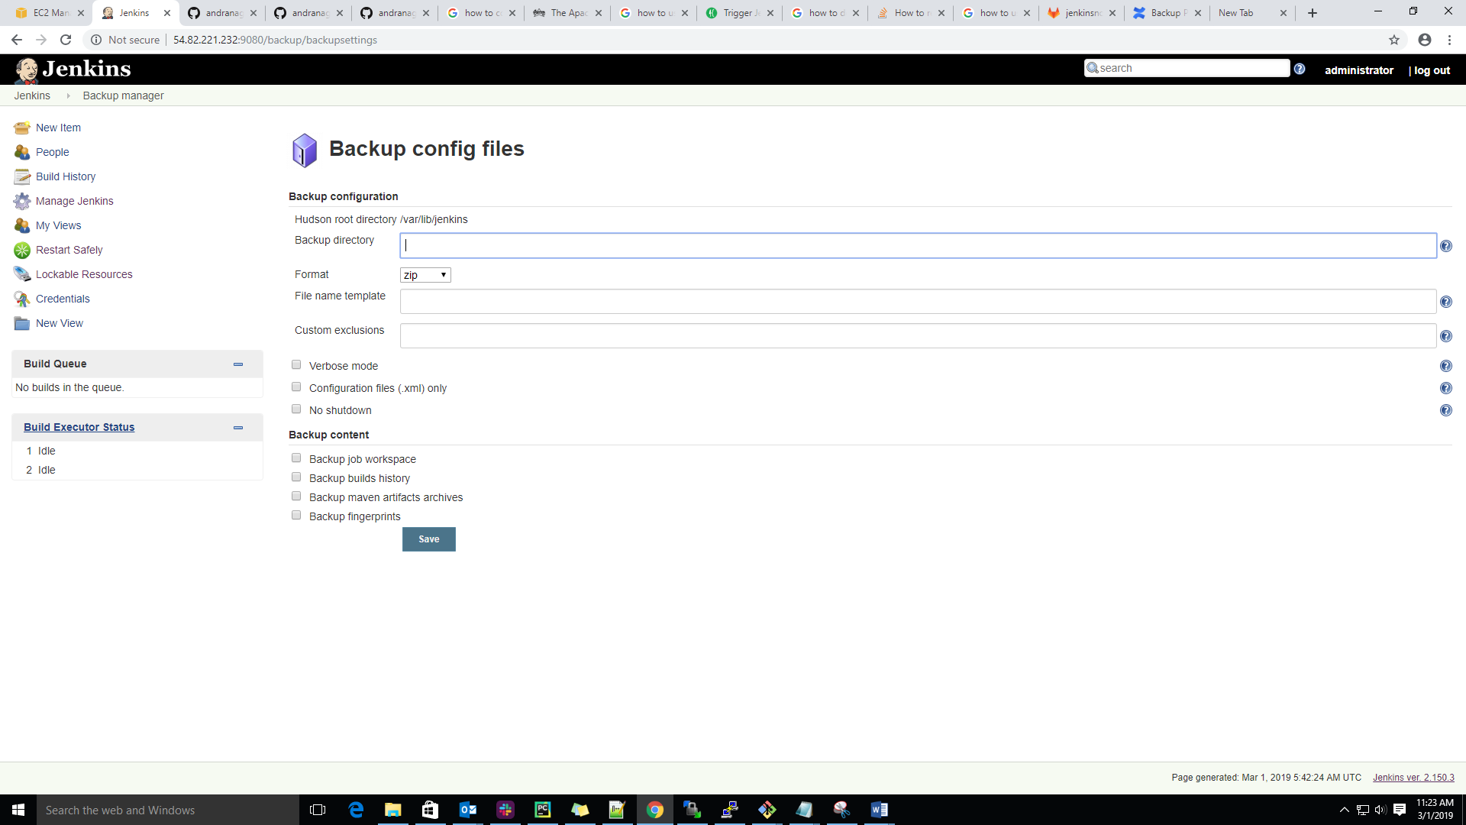

Step 4: Here, we need to choose the backup format as shown below directory.

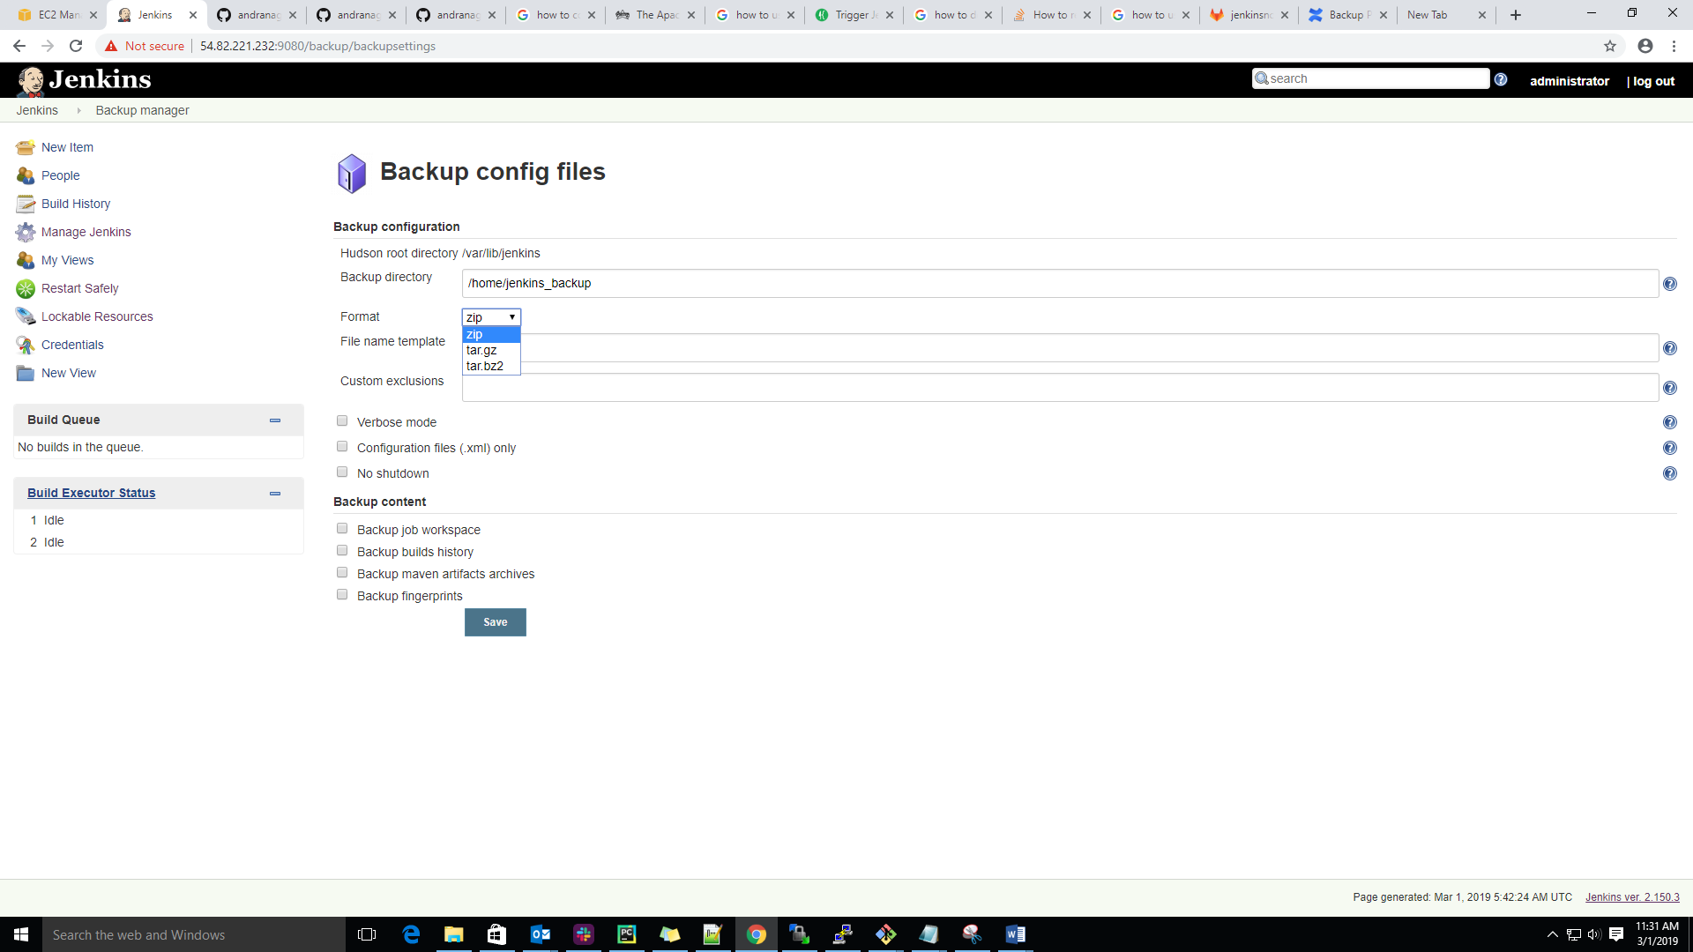

Here we will choose the filename as shown below screen shot

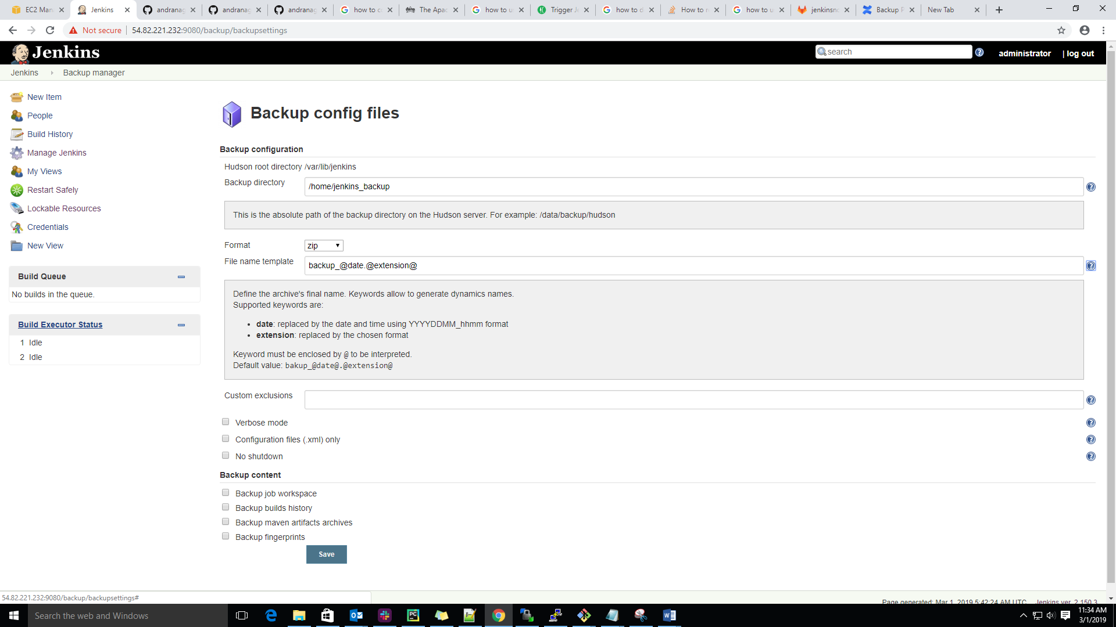

Step 5: Here, select the Build job workspace backup then click on save as shown below screen shot.

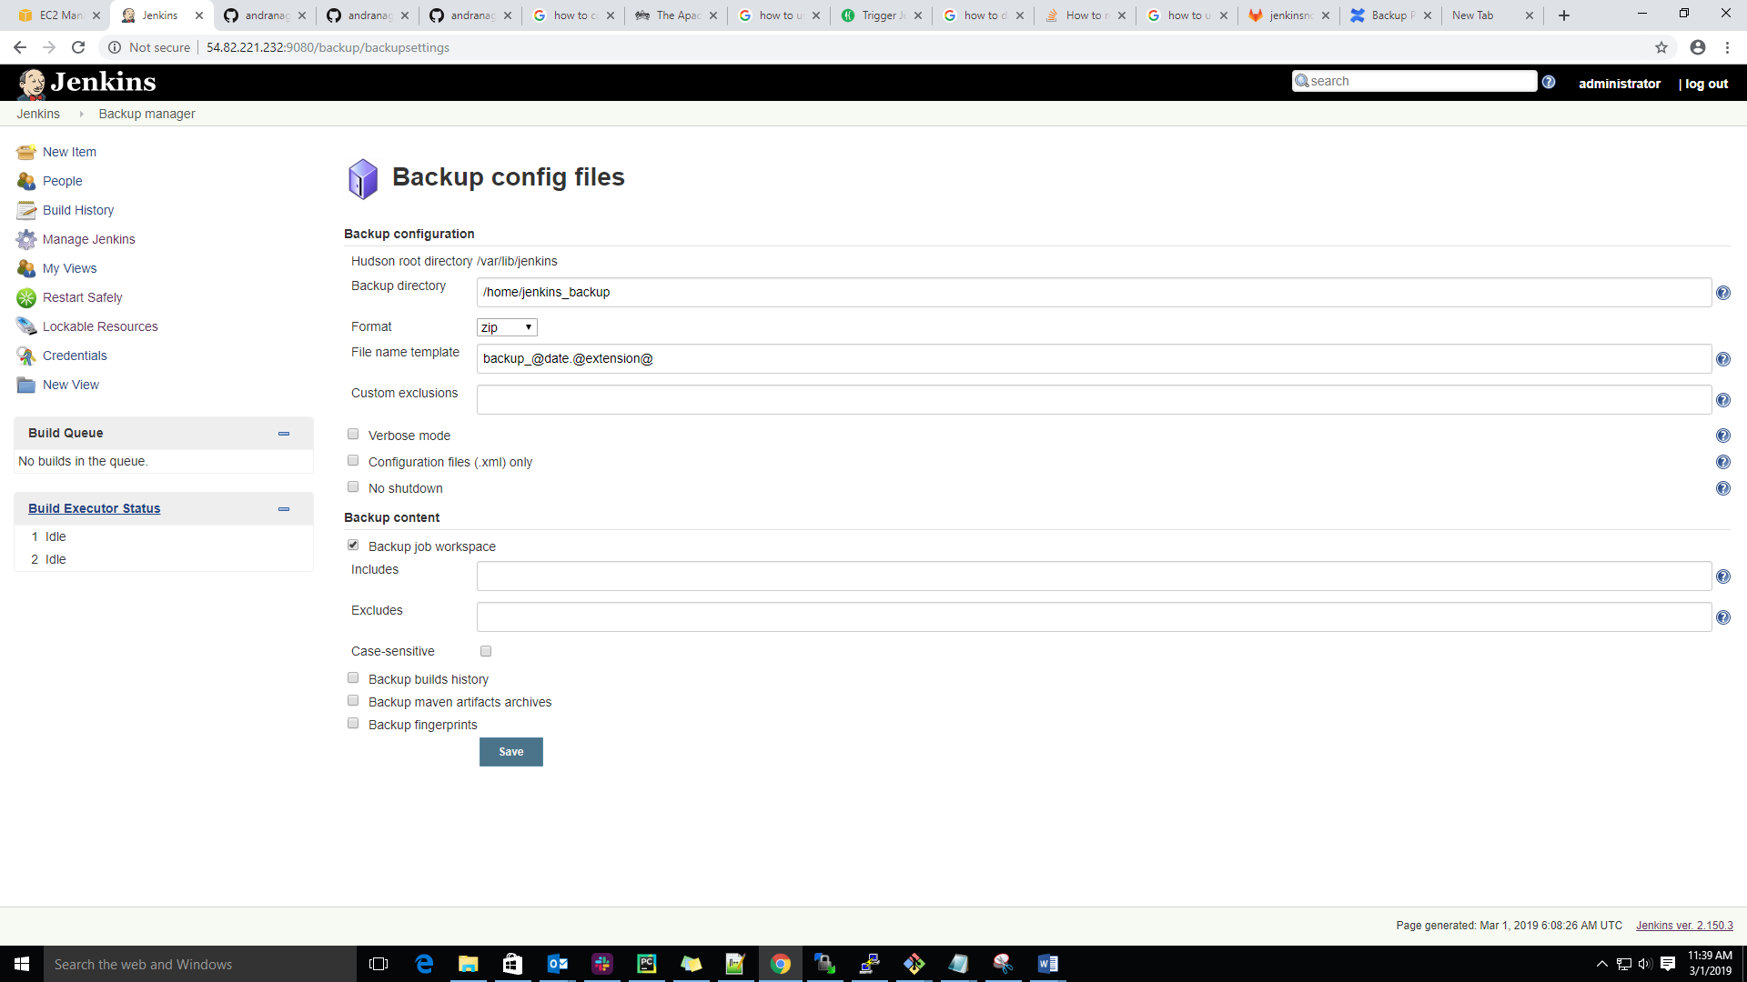

Step 6: Now, we will start take a backup click on Backup Hudson configuration as shown below screen shot.

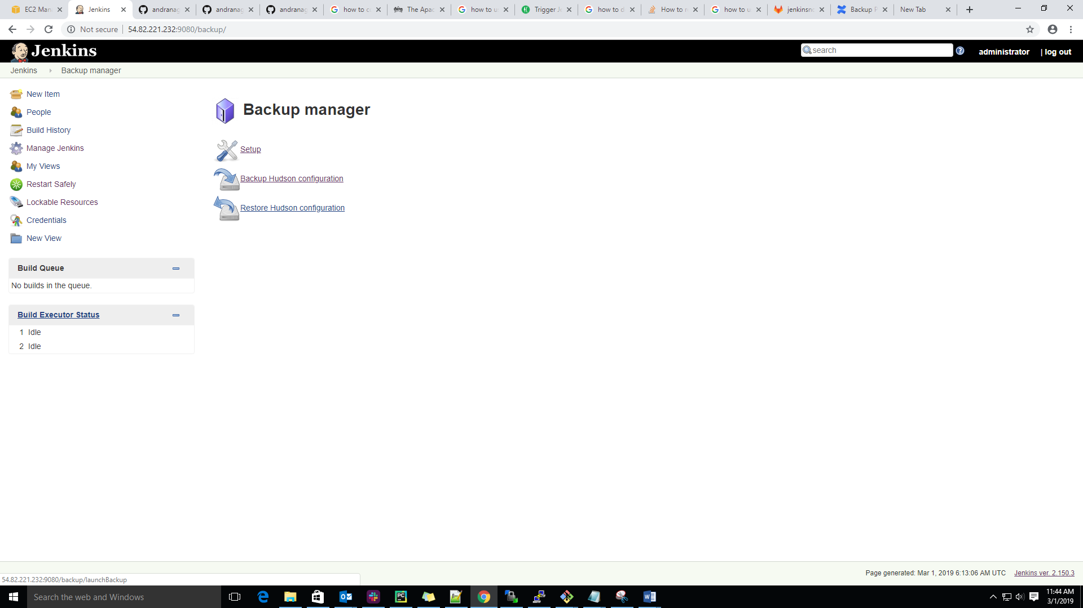

Step 7: after click on Backup Hudson backup below window come and after completion of Jenkins backup we will get the below message.

